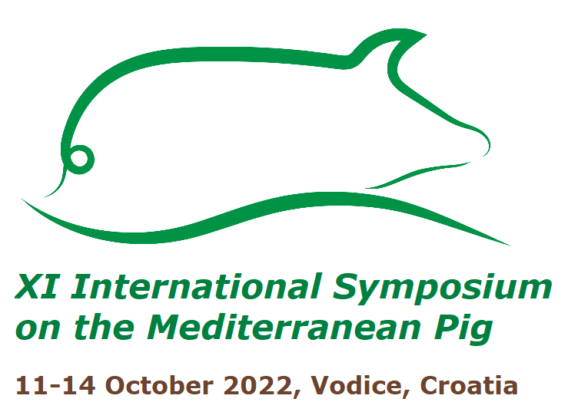

Title proposal
(Please send it before April 17th, 2022)

NAME Insert text here SURNAME Insert text here
COMPANY/UNIVERSITY Insert text here
EMAIL Insert text here
TITLE Insert text here
AUTHORS Insert text here
TOPIC
☐ 1. Animal Breeding and Genetics
☐ 2. Production Systems, Feeding and Environment
☐ 3. Animal Health, Welfare and Reproduction
☐ 4. Meat and Product Quality, Innovations and Traceability
☐ 5. Socio-Economic Aspects
PREFERRED PRESENTATION
☐ Oral ☐ Poster
ADDITIONAL INFO
Insert text here

Please send the form to: medpig2022@agr.hr
Detailed info on the Symposium available at: https://medpig2022.agr.hr/

